FLIGHT DESIGN PROJECT

Aengus Drennan

Louis Paine

Liam Taylor

Kyle Thompson

Syed Tirmzi

John Viljoen

Tutor: Mark Lowenberg

**Design Process**

We began our design process by deciding what aerodynamic features to include in our wing. We reached the conclusion that the following were important for an aerodynamically well-performing design:

* **Camber:** Increases maximum lift coefficient, thus minimising the stall speed. As a trade-off, it also increases drag.
* **Taper:** Increases aspect ratio to improve lift. The resulting smaller wing tip would also reduce drag by reducing the size of wingtip vortices.
* **Sweep:** Though not necessarily particularly useful for our basic wing tests, wing sweep was included in our project criteria as an objective. In general, sweep has the advantage of increasing stability, and delaying shockwave drag, so is often used on higher-speed aircraft.
* **Wing twist:** Decreases angle of attack at the wing tip, and therefore reduces vortex production and drag of the wing. Furthermore this would reduce the lift at the wing tip and therefore reduce the moment acting at the root.

We quickly realised that the structural deflection was the crucial factor, as a deflection that exceeded the maximum of 40mm would instantly void the design. We therefore began the design process from the structural angle, by writing a programme to calculate bending deflection from second moment of area in C. This allowed us to experiment with a multitude of values and aerofoils in a short period of time.

The specification advised a tip thickness of no less than 20mm, and as we were inexperienced and unfamiliar with the manufacturing process (CNC wire foam cutter), we elected to be on the ‘safe side’ and chose a thickness of 30mm for the tip. We also felt that a thicker wing would perform better on the dynamics test, because it would make it stiffer, thus decreasing the amplitude of vibrations.

We specified two different NACA profiles for the wing tip and the wing root as well as a twist in the wing in order to have high lift at the wing root (NACA 4420, 200mm chord) and low lift at the wing tip (NACA 0027, 110mm chord). This reduced the vortex production at the wing tip and therefore decreased drag, as well as reducing the moment the wing experiences around the root due to centering the forces as close to the root as possible.

**3-view CAD Drawings**

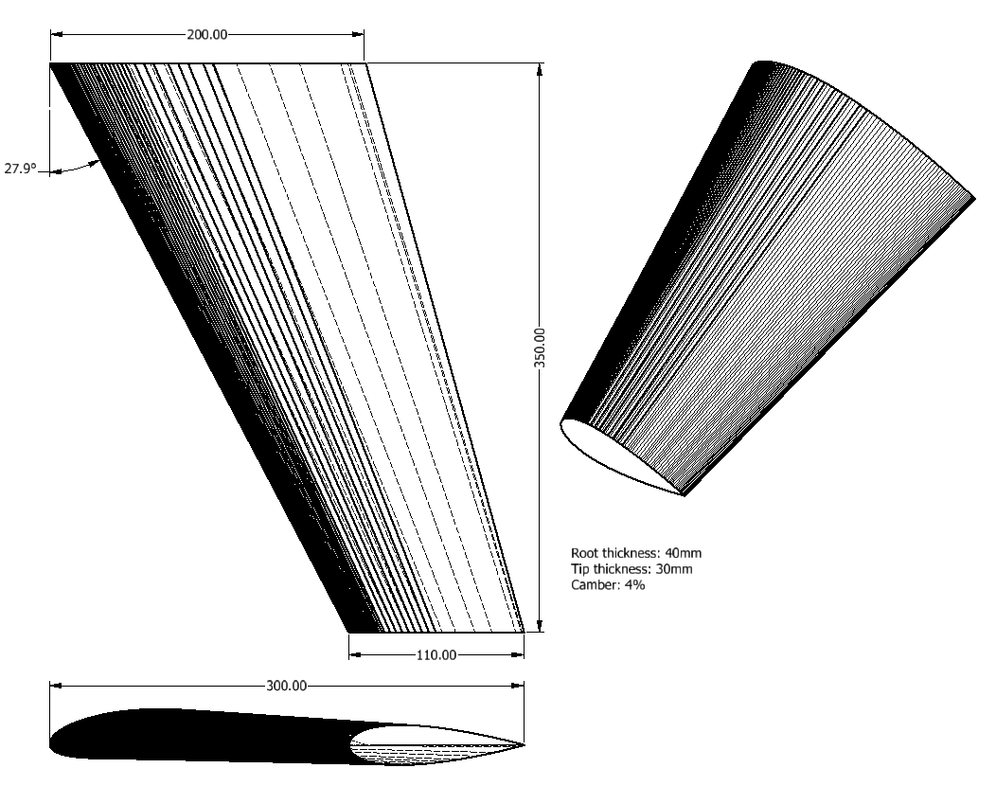

**Figure 1.1**

The above technical drawing shows half-span, sweep angle, and chord lengths and thicknesses. Value stated for camber applies to root cross-sectional profile only.

**Structural Behaviour**

Two methods were used during the theoretical analysis of the bending deflection of the wing with a 300g load; a constant geometry analysis using Euler-Bernoulli bending theory, and a varying geometry analysis, using an iterative sectioning method. The complex geometry of the aerofoils limited our conventional methods for determining the second moment of area, so a different approach, using an approximating formula1, was used:

**I = 0.036c t (t2 + h2)**

where the parameters c, t and h are chord length, maximum thickness and maximum camber respectively.

This equation allowed for an upper and lower limit to be calculated, done so by applying Euler-Bernoulli Beam theory with the geometry of the root aerofoil (lower limit), then with the tip aerofoil (upper limit):

Upper limit: 15.7mm

Lower limit:3.44mm

To find the true deflection with a wing tapered between the two aerofoil sections, a more complex analysis had to be considered. First, to make use of the second moment of area formula, the desired parameters defining the cross-section geometry needed to be calculated at any point x from between the root and tip aerofoils. This is demonstrated in the following equation, where *y* is the parameter, *yrt* is the value of the parameter at the wing root, *yr* is the ratio of the parameter length at the tip aerofoil to length at the root, and *ws* is the half span:

**y = yrt+((yrt*yr)/ws-yrt/ws)*x**

           The program written asks the user for wing geometry parameters, the number of iterations to be used (‘*slices*’) and the material’s Young’s Modulus. Using the number of iterations and the wing span, the wing is split into small components, allowing the program to calculate the deflection due to load, bending moment and rotation at the tip of each section, where the formula for the second moment of area was implemented for each increment of the cumulative bending formula.

           Using this model, and the geometries we chose for our foam wing design, the program predicted a total tip deflection of 5.113 mm. This is how our wing performed in practice:

Test Results

|  |  |  |  |  |  |  |  |
| --- | --- | --- | --- | --- | --- | --- | --- |
| Load | 0 | 50 | 100 | 150 | 200 | 250 | 300 |
| y/mm | 88 | 91 | 94 | 98 | 103 | 107 | 112 |
| dy/mm | 0 | 3 | 6 | 10 | 15 | 19 | 24 |

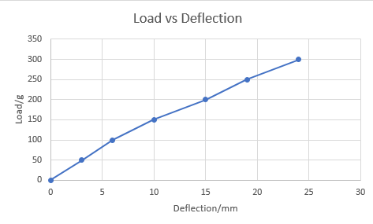

**Figure 2.1**

The deflection is significantly higher than predicted, however this is due to considerable deformation at the root of the wing, where it had been mounted; After structural testing, we noted that the rods supporting the wing had pressed into the material, resulting in deflections at the root being amplified at the tip, justifying the extra 19mm deflection.

It is evident that our wing over-performed significantly, so it can be said that we could have designed a wing of less mass achieving the same performance requirements. In retrospect, we probably would have come to a compromise such as this if we hadn’t been restricted by the constraints previously mentioned in the *Design Processes* section.

To conclude, the wing passed the structural test, as predicted, however in practice, the higher second moment of area of the aerofoil profiles across our wing were redundant, as the structural performance requirement could have been achieved with a less stiff wing, resulting in a significant reduction in mass.

**Aerodynamic Behaviour**

Using data found online for similar aerofoils to ours, we calculated an initial prediction for the value of dCl/dɑ. This was converted to a 3D prediction with the Helmbold-Diedrich formula. The Clmax value was also calculated using data from an online database.

Our predicted primary characteristics are shown below:

L/Dmax = 34.7000

Clmax = 1.0473

dCl/dɑ = 3.0019

Experimental data:

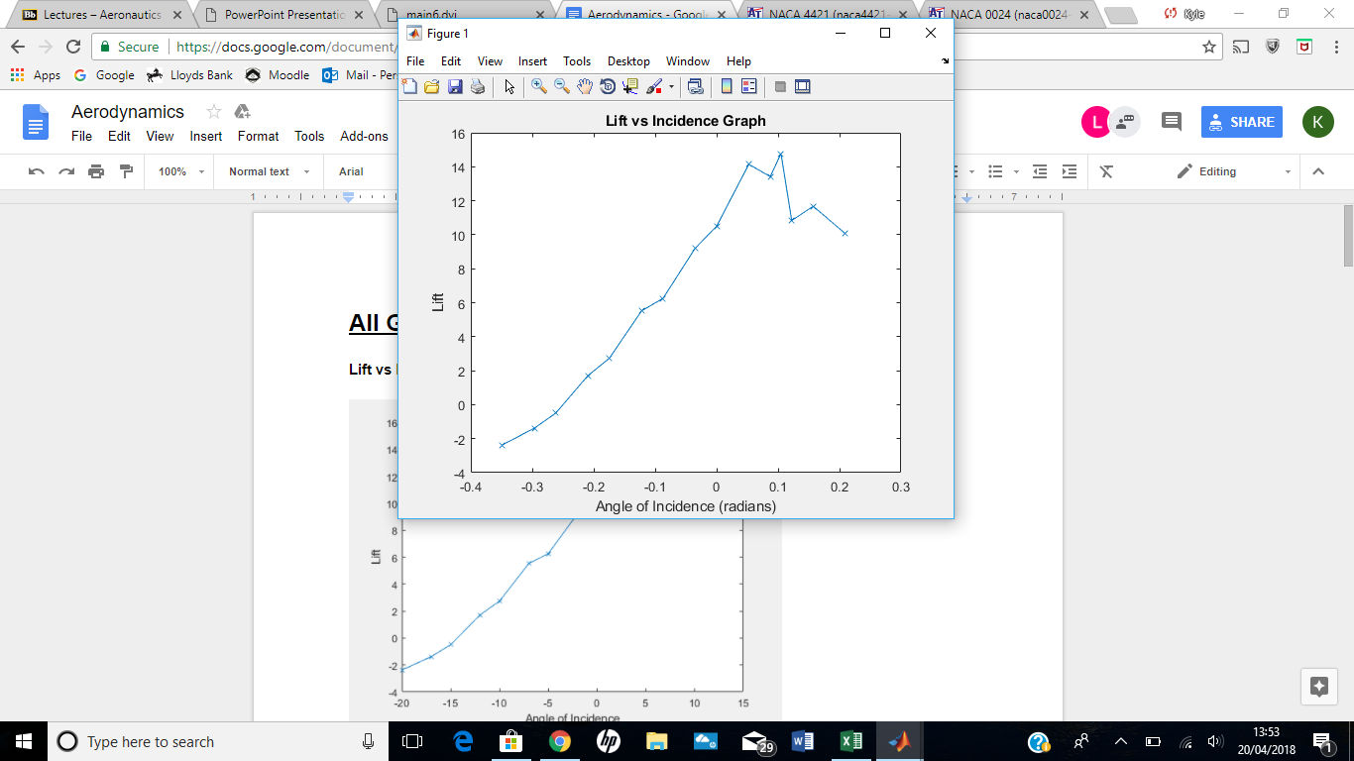

**Figure 3.1**

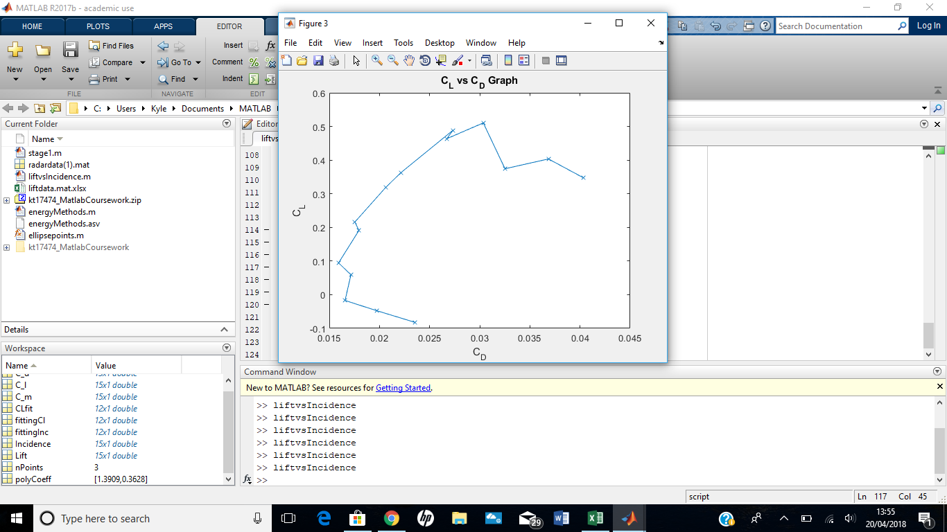

**Figure 3.2**

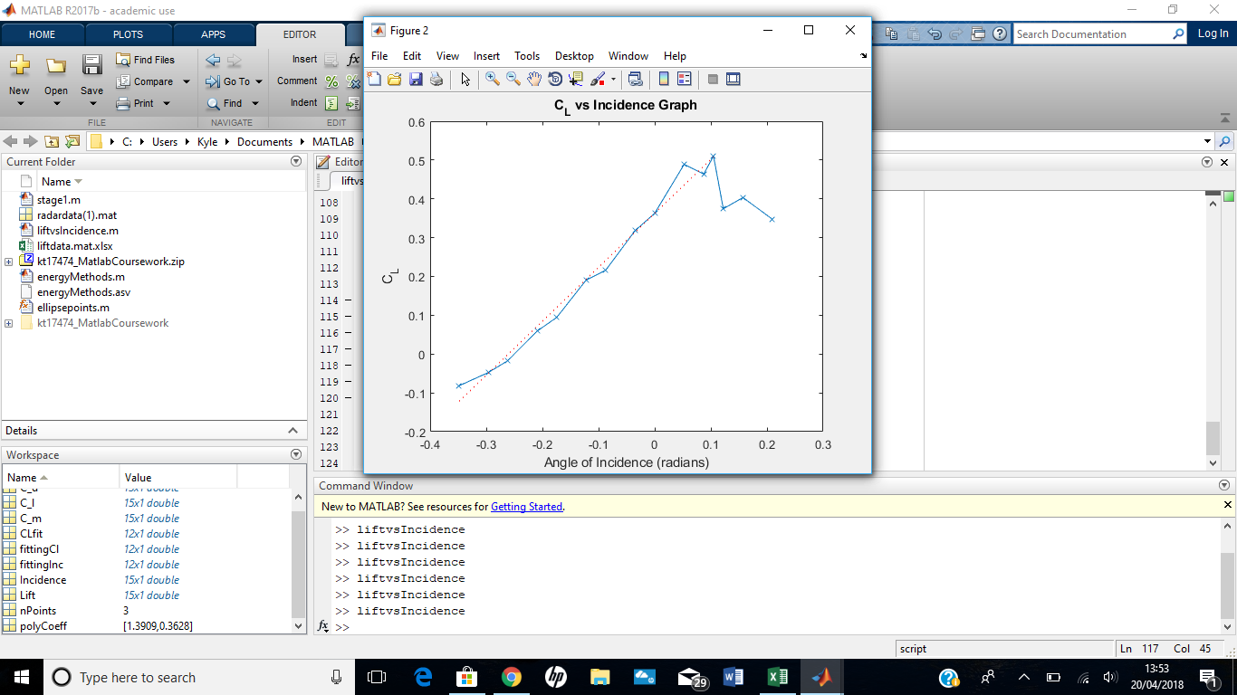

**Figure 3.3**

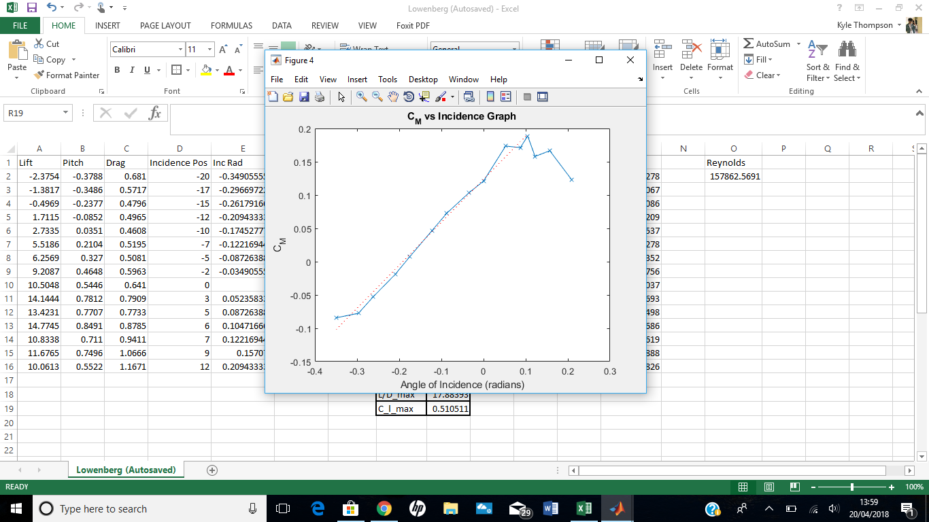

**Figure 3.4**

The aerodynamic data in our plots follows the expected trends but as discussed, is generally lower than our predictions. These are the experimental values for our primary characteristics (the Aerodynamic data used is at the end of this report):

L/Dmax = 17.8839

Clmax = 0.5105

dCl/dɑ = 1.3909

Aerodynamic centre = 48.0722mm

Our wind tunnel results were significantly less than our predicted values for dCl/dɑ, Clmax and L/Dmax which were all approximately twice as large as our experimental values. We think that this was probably the product of two main factors. Firstly, we over-emphasised the importance of passing the structural test by maximising the thickness of the wing. There was noticeable early flow separation in the wind tunnel, as demonstrated by the ‘thread on a stick’ tool, and the graphical results show that the onset of stall was rapid after reaching Clmax. Both of these observations confirm that our wing lacked laminar flow. We also realised that the surface finish of the foam was quite poor, which no doubt would have greatly increased skin friction drag and therefore lowered our L/Dmax value.

**Dynamic Behaviour**

Natural Frequency of the wing is determined in order to avoid resonance, which could result in  structural damage to the wing. Our method for calculating the theoretical oscillation frequency for the wing with the accelerometer of the iPod was as follows:

f = 12(keme+mi)12

Where :

ke = Fz

me = m

Where 𝛾 is a constant (ranging between 0.23 and 0.33), *m* is the mass of the wing (50g) and *mi* is the mass of the iPod.  The stiffness of the wing was calculated using the figure and the Hooke’s Law relationship given in the formula above (ΔZ being deflection and F being load).

Therefore, before testing, our theoretical calculated oscillation frequency was between 16.27, 13.59Hz without ipod attached, and 4.97Hz, 5.07Hz with ipod attached.

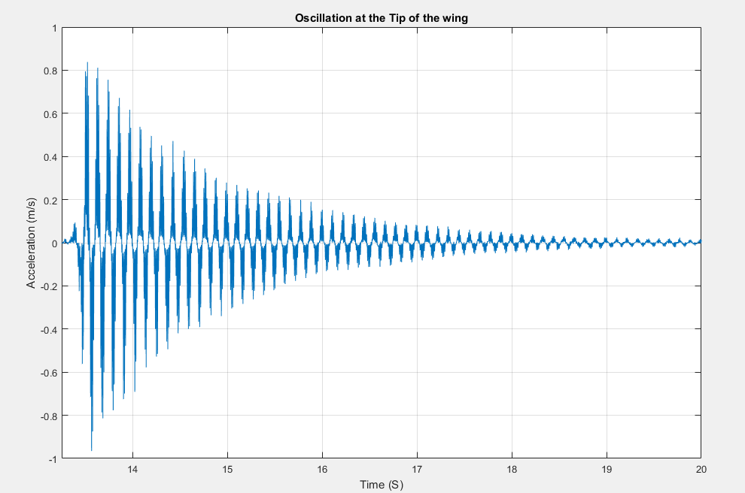

**Figure 4.1**

Our experimental results (fig 4.1) for the oscillation on the tip of the wing showed 54 oscillations. The ipod used 1625 measurements of the acceleration in the graph, and the ipod was measuring at 100Hz sample rate. Therefore 16.25 seconds passes during 54 oscillations and therefore experimentally the frequency of oscillation with the ipod attached is 3.32Hz. This is 66.8% of the smallest theoretical value for this scenario.

The appreciable discrepancy between the calculated oscillation frequency and the observed oscillation frequency is due to primarily the fact that the wing slipped substantially in the mount whilst we recorded the results. Other forms of error are that the ipod was not placed perfectly at the end of the wing, as well as the ipod not being an exact point mass, both of which are assumptions we made. Both of these assumptions should have made the experimental frequency larger than the calculated frequency, an effect which cannot be seen in our comparison between experimental and theoretical. Furthermore the mount was slightly inset on the wing, therefore shortening the effective length of the wing more, which again should have reduced the value of the calculated value to be smaller than the experimental value. Therefore this barely explains the much larger than experimental, calculated value, as we do not believe that the movement in the mount caused all of the error, as the graph still shows a clean damped oscillation, which is not what we would expect from an unstable mount.

On the day when we recorded the results the demonstrator said that because our wing was so thick the oscillation frequency exceeded the sampling rate of the ipod’s accelerometer. However if this was the case I do not believe you would see such a clear sinusoidal waveform as you do in figure 4.1, and more than this the experimental results would not have been as close as they are to the theoretical results. However if this was the case, this could be the reason that the oscillation frequency was not correctly measured.

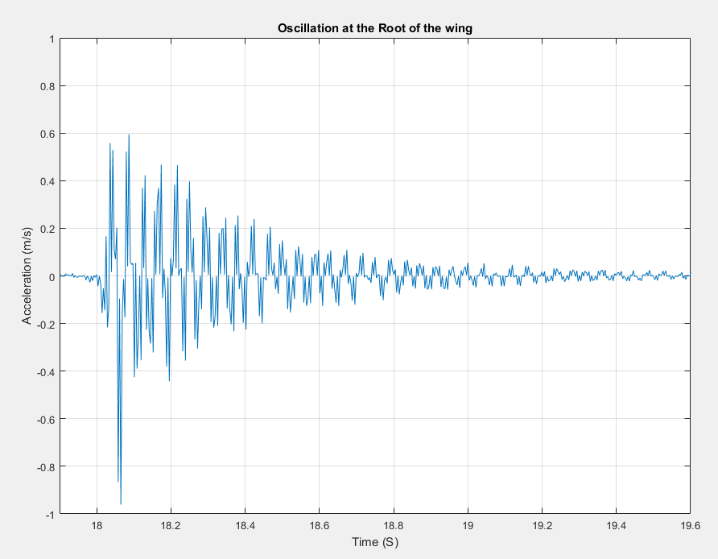

**Figure 4.2**

Here in Figure 4.2 we observe 32 oscillations after 361 measurements at 100 Hz sampling rate at the root, therefore the frequency of oscillation is 8.86Hz.

The damping graph shown in Figure 4.3 was plotted using the oscillation data obtained. The damping graph resulted in a similar graph to a critically damped system. This shows that the wing returns to equilibrium as quickly as possible once it starts oscillating. The damping in the wing occurs due to the  energy losses as the wing vibrates due to drag through the air as well as internal frictional losses inside of the material the wing is composed of. There was no constant amount of energy provided to the wing and hence the wing returns back to its equilibrium position.

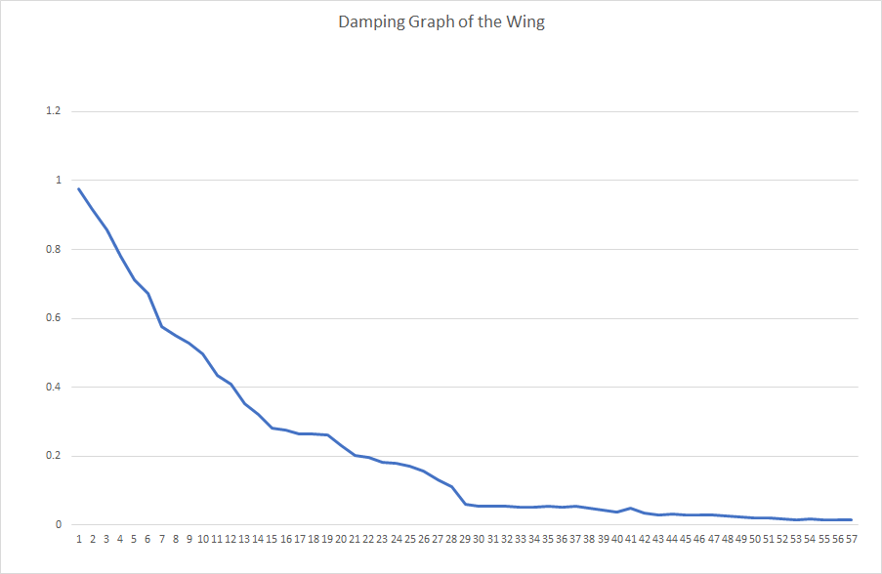

**Figure 4.3**

**Conclusion**

It can be concluded that our design was far from optimal; while performing well structurally, there was too big a trade-off on aerodynamic performance. Evidently, the biggest flaw in our design was the thickness of the chords, especially at the tip. We could have come to more of a balance between aerodynamic performance and structural/vibrational performance be using aerofoils of less thickness to reduce drag. Aside from our discrepancies in vibrational data, it is safe to say that we overperformed in those categories, leaving ourselves significantly underperforming on lift and L/D ratio. In saving material by decreasing thickness, we would also have reduced the volume of the wing: another objective that we underperformed on.

**References**

1https://ocw.mit.edu/courses/aeronautics-and-astronautics/16-01-unified-engineering-i-ii-iii-iv-fall-2005-spring-2006/systems-labs-06/spl10b.pdf

**Aerodynamic Data:**

